**KIET Group of Institutions, Ghaziabad**

***Name of Department***



**PROJECT BASED LEARNING**

**ON**

**MODERN PERIODIC TABLE**

**SUBJECT: Data Structure Using C lab**

**(KCS-553)**

**Submitted By:**

**Aman Khan(2100290110018)**

**B-Tech/Csit(3-A)**

**ACKNOWLEDGEMENT**

I’ve got this golden opportunity to express my kind gratitude and sincere thanks to my subject faculty **“Mr. Vinay Kumar”**, Computer Science and Information Technology Department, **KIET GROUP OF INSTITUTIONS** for their kind support and necessary counselling in the preparation of this project report. I’m also indebted to each and every person responsible for the making up of this project directly or indirectly.

I must also acknowledge or deep debt of gratitude each one of my colleague who led this project come out in the way it is. It’s my hard work and untiring sincere efforts and mutual cooperation to bring out the project work. Last but not the least, I would like to thank my parents for their sound counselling and cheerful support. They have always inspired us and kept our spirit up.

**Aim**

To display the elements of maordern periodic table as per the requirements of the user and to alter it.

**Objective**

we used Array concept of data structure to achieve the aim and implement it in our working project.

In Mordern periodic table one can delete ,add elements, and print the properties of elements

It also comprises of displaying all the element

**Abstract**

With this program we can find any element using its atomic number or we can finds its atomic number if we know the name of the element and we can make amendment in the periodic table too like shifting elements, deletion and all.

**Basic principle**

It is used to store the properties of elements and and it’s chemical nature also.

We have made several functions in our system to perform different tasks

1. void add(): This function is used to input or add the information of new element to the program.
2. void explor(): This function is used to explore the stored information in the file created.
3. void mainscreen(): It is included in source code of project file in order to print the text style and to control its color.
4. void mainscreen(): This function is used to print the main screen or menu of the project.

* **Storage of Element Information:** In the project, you can add any new element with its name, symbol, atomic number, atomic weight and its some important properties. When new element information is to be added to this Modern Periodic Table, you have to enter 1 in the main menu and input information in given [format](https://www.codewithc.com/python-format-with-conversion-stringifiation-with-str-or-repr/). These information are stored in file created on the hard disk of computer by program itself.
* **Exploration of element Information:** Another main function of this project is to explore or to display the stored information. You can [search](https://www.codewithc.com/breadth-first-search-in-c/) an element by using any of the following method:
  1. By name of element
  2. By symbol of element
  3. By atomic number of element
  4. By atomic weight of element
* If you press 3 in the main menu, the program will be terminated.

**Methodology**

we are using the following technology for this :-

* **Singly linked list** : A singly linked list is a type of linked list that is unidirectional, that is, it can be traversed in only one direction from head to the last node (tail). Each element in a linked list is called a node. A single node contains data and a pointer to the next node which helps in maintaining the structure of the list.
* **Array :**Array in C can be defined as a method of clubbing multiple entities of similar type into a larger group. These entities or elements can be of int, float, char, or double data type or can be of user-defined data types too like structures.
* **Structure:** Structures (also called structs) are **a way to group several related variables into one place**. Each variable in the structure is known as a member
* of the structure. Unlike an array, a structure can contain many different data types (int, float, char, etc.).

**Some snippet of output screen:**

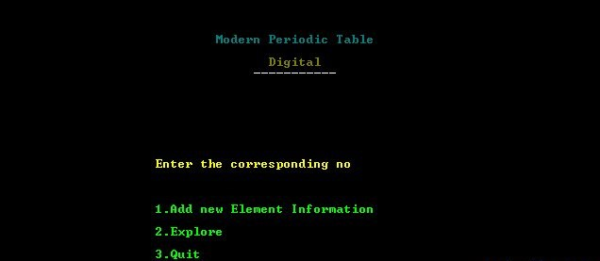

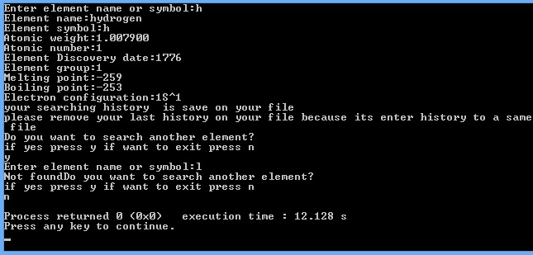

**Reference link**

**https://www.codewithc.com/modern-periodic-table-c-project/**

[**https://www.w3schools.com/c/c_structs.php**](https://www.w3schools.com/c/c_structs.php)